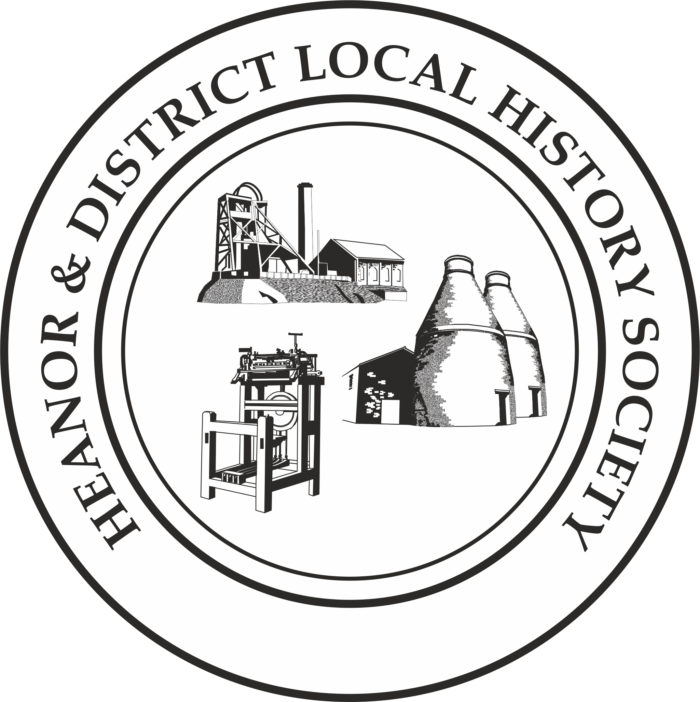
We want your memories! As part of an ongoing project, the Heanor & District Local History Society wants to hear from YOU.
This month’s topic is: Christmas.
If you normally attend our meetings, just fill in the form and hand it back at the next meeting.
If you don’t attend our meetings, then you can send us an email with the information (mail@heanorhistory.org.uk), or post the form to 12 Walton Court, West Hallam, Ilkeston, DE7 6NS.
We would rather that you didn’t send us information anonymously, but nobody’s name will be published unless you have specifically given us permission to do so. In particular, we WILL NOT publish anything which of a personal or potentially sensitive nature.
Name | Address
Telephone
Email address
Are you willing for us to include your name if we publish your memories? |  | Yes / No
Would you be prepared to discuss this or related information further? |  | Yes / No

Please try to focus on one particular Christmas from your childhood.
Where did you live as a child? What were your family circumstances (eg. how many children in the house, etc)?

Roughly when was this?
What can you remember about the lead up to Christmas? (e.g. what was happening in the shops, letters to Santa, etc.)

What Christmas activities took place at school?

Please describe Christmas day in your house when you were a child.
What did you have to eat on Christmas Day?
What was the most memorable Christmas present you received?

What has changed about Christmas since you became an adult? When do you think Christmas started changing (for you)?

Please use a separate sheet if necessary. Thank you

